CBA/La Salle Relays
Saturday April 11th, 2026
9am
La Salle Institute
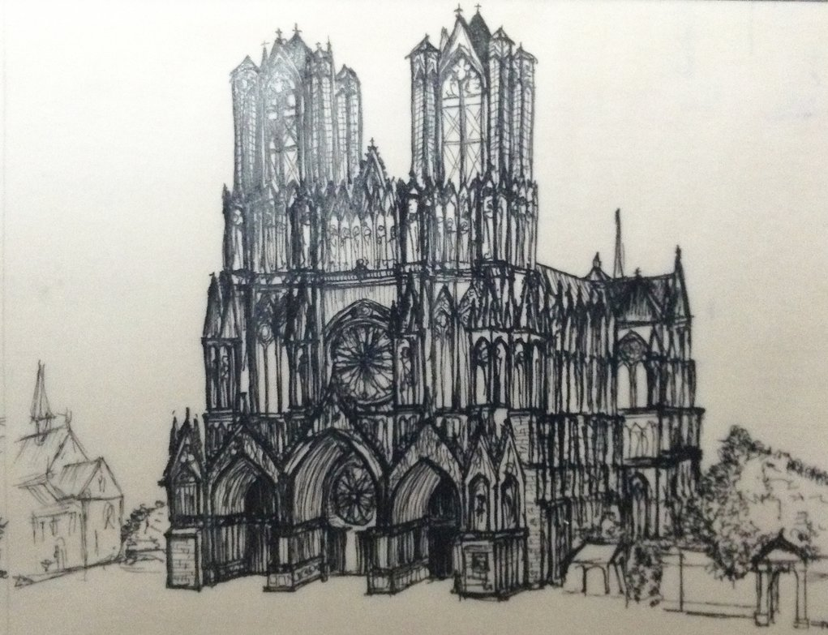
Cathedral at Reims, France
Birthplace of St. John Baptiste De La Salle
La Salle Institute Christian Brothers Academy
174 Williams Rd. 12 Airline Dr.
Troy, NY 12180 Albany, NY 12205


Coaches:

We would like to invite you and your team to the CBA/La Salle Relays. The

meet takes place on its traditional second Saturday of April on 4/11/2026 beginning at 9am.

Our unique entry fee system of using either a blanket entry or paying for each relay entered

allows you to cater your entry to your team’s specific needs. The meet also offers many

frosh/soph events including shot, disc, long jump, and triple jump.

The meet will start at 9:00am with all field events and the 4 x 1600. In past

years, the meet has been completed in about 6 hours. We hope to see you and your

athletes on April 11th .

Sincerely,
Christian Brothers Academy La Salle Institute
Tom O’Malley, Head Coach John Leonard, Head Coach
James Schlegel, President Kevin Calacone, President
Charles Abba, Principal Steve Sgambelluri, Principal
Blaine Drescher, Athletic Director Kevin Galuski, Athletic Director
Pat Moran, Athletic Director

Information:

1. Scoring will be on a 10-8-6-5-4-3-2-1 basis, varsity events only. Only one person per school can score in the 200, steeplechase, and 1500/mile. "B", "C", etc. non-hurdle track relays are eligible for awards and can score. Only one hurdle relay/field relay per school can win awards/score. (You can enter multiple hurdle/throws relays, but they are ineligible for awards and scoring purposes.)

2. All races will be FAT by First Across Timing.

3. Medals will be given to the top three teams in each event with ribbons for 4th through 8th .
The top three teams, boys and girls, will receive team plaques.

4. A blanket entry allows you to enter 9 varsity track relays, 5 frosh/soph track relays, 1 relay for each jump, one shot and one disc relay for varsity and frosh/soph, and two entries for each individual event.

5. You can enter additional shot or disc relays if you don’t enter all four jumps relays or by paying the extra entry of $25 for each extra relay. To give an exaggerated example, you could use the blanket entry, enter nine 4 x 1600 relays, and get all your varsity runners home nice and early. Only one team per school for the jumps relays. Since La Salle has 2 runways, we are holding Frosh/Soph LJ and TJ relays.

6. In field relays, one or two person teams can score and receive awards.

7. Entries will be done on milesplit. Entries must be completed by Thursday April 9th 10:00 pm at ny.milesplit.com. Enter up to eight names per track relay. For field events just enter individuals and the computer will add the distances for your relay total. For throws relays, if you enter more than 3 athletes, the computer takes your top 3 as the “A” relay, the next 3 as the “B” relay, etc. (Remember for each extra set of three athletes you need to pay an additional entry fee.)

8. Please supply your own batons, starting blocks, and throwing implements.

9. The frosh/soph shot and disc will use varsity implements.

10. Spikes may be worn (1/4 in. or smaller.)

11. Jumps: Only 1 team per school in the LJ, TJ, HJ, PV, F/S LJ, F/S TJ boys and girls.
There is no F/S HJ or PV—only LJ & TJ; shot & disc.

12. Results will be sent to Jon Broderick’s site (section2harrier.com.) and be up on firstacrosstiming.com.

13. There will be a concession stand with food, meet T-shirts, and programs.

14. Questions: John Leonard jleonard@lasalleinstitute.org

ORDER OF EVENTS
9am 6400 relay Varsity girls, varsity boys
(Boys and girls may run together.)

4 x 100H Frosh/soph girls (30”), varsity girls (33”)
4 x 110H Frosh/soph boys (36”), varsity boys (39”)
This will be run as shuttle hurdles.

4 x 200 relay Varsity girls, varsity boys
4 x 800 relay Varsity girls, varsity boys
4 x 800 relay Frosh/soph girls, frosh/soph boys--may run together

200m dash Varsity girls/varsity boys Final on time

Invitational 1500 Varsity girls/frosh-soph girls
Michael C. Flowers Invitational Varsity Boys Mile Run
Frosh-soph boys Mile Run
Varsity and F/S may run together. Boys and girls will run separately.

4 x 100 relay Varsity girls, varsity boys, frosh/soph girls, frosh-soph boys

Sprint Medley Varsity girls, varsity boys
(400, 200, 200, 800--May use waterfall start.)

3 x 400H Varsity girls, frosh/soph girls (both at 30”)
3 x 400H Frosh/soph boys (33”), varsity boys (36”)

Distance Medley Varsity girls, varsity boys (1200, 400, 800, 1600)

4 x 400 relay Varsity girls, varsity boys, frosh/soph girls, frosh/soph boys
(Frosh/soph may use waterfall start.)

2000m Steeplechase Varsity girls at 30”/Varsity Boys at 36”

9am High jump: Girls (opening height: girls 3’6 up 3” until 4’6 then 2”)
Then Boys (boys 4’ 6 up 3” until 5’6 then 2”)

Pole vault: Girls and boys combined (girls: 5’, 6’ then up 6”; boys 6’, 7’, then up 6")

Long jump: F/S Boys (pit 1—closest to turf field); F/S Girls (pit 2—closest to track)
Then Varsity Boys (pit 1) Varsity Girls (pit 2)

Triple Jump: follows LJ F/S Boys and Girls Then Varsity Boys and Girls
(pit 1 Boys, pit 2 Girls)

Shot put: Boys then girls followed by frosh/soph boys, then frosh/soph girls.
Discus: Girls then boys followed by frosh/soph girls, then frosh/soph boys.

ALL FIELD RELAYS ARE 3 PERSON TEAMS, ADD UP BEST PERFORMANCES.
THREE JUMPS/THROWS SHOT, DISC, LJ, TJ. TIES BROKEN BY BEST JUMP OR THROW.
IF STILL TIED, 2ND PERSON’S BEST JUMP OR THROW, ETC.
Two or one person teams are eligible for awards & can score in all field relays.

You can have more than one relay per track events (except hurdles) and the throws—but must pay extra for the additional team(s). Only one field event team/hurdle relay per school can score/win awards.
More than one track relay (except hurdles) per school can score/win awards.
ENTRY FEES - Use Method A and/or Method B to determine your fee.

Method A Blanket Entry (Check one of the following)

Boys (Varsity and F/S) team entry __________ $200
Girls (Varsity and F/S) team entry __________ $200
Combined (Varsity and F/S) entry __________ $300
Frosh/soph only entry ___________$100 (boys or girls)_________$175 (coed)

The blanket entry entitles you to 9 varsity track relays, 1 entry per field relay, 5 frosh/soph track relays, and 1 frosh/soph LJ,TJ, and shot and disc relay for each team (boys or girls) that you enter. You also get 2 entries in the open races: the 200, the 1500 for girls and the mile for boys, the frosh/soph 1500 for girls and mile for boys, and the steeplechase. The F/S only entry entitles you to 5 track relays, 1 entry per field relay, and 2 entries for the 1500/mile.

Method B Extra Relays/Minimum Entry

If you wish to enter extra relays beyond what is allowed by the team entry or if you have a small team and do not want to pay the full cost of the blanket entry, use this method.

Please put down the number of relays and individuals you are entering in each category.
Varsity girls __________ Varsity boys __________
Frosh/Soph girls __________ Frosh/Soph boys __________
Girls 1500 ___________ Boys Mile ___________
Girls 200 ___________ Boys 200 ___________
Girls Steeple _________ Boys Steeple__________

No. of Relays x $25 __________
No. of 200/1500/mile/steeple x $10 ___________
Total ___________

Method A Total __________ + Method B Total __________ = Total Entry Fee __________

Checks payable to “La Salle Institute”

This form must be in our hands NLT Wed. April 8th. Mail, email, or fax to :

John Leonard
La Salle Institute
174 Williams Road
Troy, NY 12180
Fax: 518-283-6265
Email: jleonard@lasalleinstitute.org

Reminder:
Mail, email, or fax your entry--no later than Wed. April 8th. Checks/vouchers may be brought to the meet.

Name of School__________________________________________ School Phone__________________

Boys’ Coach ___________________________________________ Home Phone___________________

Email_____________________________________________ Cell________________________

Girls’ Coach ___________________________________________ Home Phone___________________

Email______________________________________________ Cell_______________________
New for 2026:
If winter-like inclement weather makes the meet impossible to be held outdoors, the meet will move to the CBA Bubble and its 4-lane 200m track facility. This will entail a change in a number of events – for example no disc, 400H, or steeple – but will allow us to still compete on April 11th.
Any decision on this will be made on Friday April 10th to allow coaches to make changes to entries that evening.

